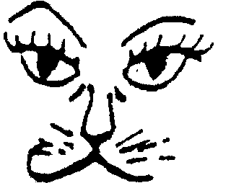
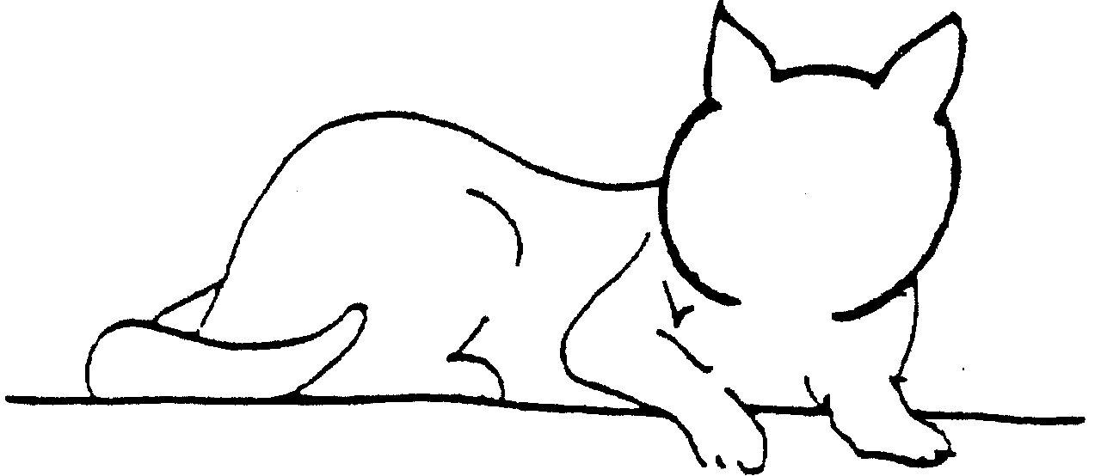

Eye Exercise to Improve Convergence

This exercise is designed to correct esotropia or weakness of the muscles of the eye which help with convergence, the ability to focus on a point. Begin with this paper at a distance (at arm's length) and slowly, with practice move it closer as the eyes gain strength.

First practice crossing the eyes by holding one finger up in front of your face and looking past your finger and focusing on a point in the distance until you see two fingers.

In the same way hold this sheet in front of your eyes until you can see two cats and two faces. Without strain use your eye muscles to bring the face nearest the body onto the body and hold in this fixed position for 7 seconds.

